# Record/Upload Media or a URL from a Web Browser

Your instructor may give you two options for submitting an audio or video assignment in Canvas. These options are listed as two separate tabs in the Submit Assignment area of your Canvas assignment. Be sure to select only one of the tabs to submit your assignment, as listed below.

1. Media: You can record or upload an audio or video file you already recorded or record as needed via the Canvas media tool.
2. Website URL: Submit the Web address (URL) that contains your media file.

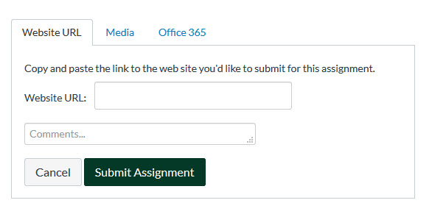

This brief document contains resources for using a Web browser to upload your assignment. If you use the Canvas Student app to upload your media submission, please see the separate document titled “Canvas Student App - Record or Upload Media or Submit Web URL.”

# Step-by-step instructions using your Web browser for the two submission options mentioned above are found at the following links.

# [How do I submit a media file as an assignment submission?](https://community.canvaslms.com/docs/DOC-10668-421254356)

# [How do I enter a URL as an assignment submission?](https://community.canvaslms.com/docs/DOC-14128-4212833582)

Please note that Canvas cannot accept media uploads larger than 500 MB.

If you have difficulty uploading your media file after following the directions at the links above, please contact the Academic Technology Center at [atc@csus.edu](mailto:atc@csus.edu), 916-278-2450 or in person at AIRC 2005.